Present perfect continuous:

Good morning to all viewers today I will be your trusted presenter

I am Anthony Coque 2 BGU "B" and we are going to talk about the

PRESENT PERFECT CONTINUOUS

Let's start, The present continuous or present progressive is one of the verb tenses of the present that is used in English, the others are the present simple and the present perfect. All of them can be used both in the indicative mood and in the subjunctive mood.

For example: My teacher is upset. Then we can deduce that the teacher is upset, because perhaps: He has been teaching the students or The teacher has been grading bad grades.

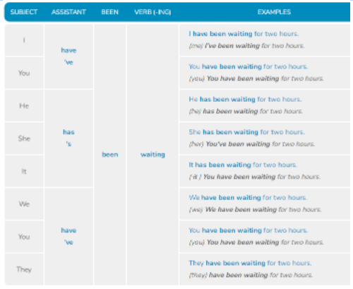This is the present perfect continuous. But we have a structure that we must follow which is:

